Enterprise Payment System (EPS)
Frequently Asked Questions (FAQs)

Table of Contents
Enterprise Payment System 2
Enrollment 2
System Set-Up 3
Mail Service Provider (MSP) 6
Funding Mail Owner’s Account as an MSP 7
User Access 8
Centralized Account Processing System (CAPS) 9
Transactions 10
EPOBOL 11
Stamps 11
Business Reply Mail (BRM) 12
Reports/Data 12
Periodicals 15
Permits 15
Mail Anywhere 16
Postage Statement Changes 16
Security 17
Miscellaneous 17

Enterprise Payment System
What is the Enterprise Payment System?
- The Enterprise Payment System or EPS allows customers to pay for products and services through an Enterprise Payment Account (EPA) funded as an Automated Clearing House (ACH) Debit or Trust Account. The EPS payment account management provides enhanced security features, centralized balance and account management, and a self-service customer experience.
What products and services does EPS support?
- EPS supports commercial, domestic and international products and services which includes First-Class Mail®, USPS Marketing Mail™, Periodicals, Electronic PO Boxes Online (ePOBOL) and Address Quality Products. Below is a list of all products/services EPS does and does not support.

Eligible Products/Services
- PO Box, Caller & Reserve Services (ePOBOL)
- Address Quality Products (AEC, AECII and ACS)
- Priority Mail
- First-Class Mail, Letters, Cards, and Flats
- First-Class Package Service
- USPS Marketing Mail, Letters, Flats, and Parcels
- Parcel Select
- Media Mail
- Library Mail
- Bound Printed Matter
- Periodicals
- International Products
- Business Reply Mail (BRM)
- Every Door Direct Mail (EDDM) – BMEU

Ineligible Products/Services
- Electronic Verification System (eVS)
- Parcel Return Service (PRS)
- PC Postage
- Scan Based Payment (SBP)
- Merchandise Return Service (MRS)
- Official Mail Accounting System (OMAS)
- Premium Forwarding Service Commercial (PFSC)
- Share Mail
- Intelligent Mail Barcode Accounting (IMbA)

What submission types does EPS support?
- EPS supports the following: Business Mail Entry Unit (BMEU) hard copy, eDoc (Mail.dat/Mail.XML), Postal Wizard and Intelligent Mail small business (IMsb) Tool.

What permit types does EPS support?
- EPS supports the following permit types: Permit Imprint, Metered, Pre-cancelled Stamps, Periodicals (CPP/PP), Postage Due and Business Reply.

Enrollment
How do I enroll in EPS?
- Currently, participation in EPS is by invitation only. To request an invitation code, contact your local Business Mail Entry Unit or send an email to PaymentModernizationMigrationTeam@usps.gov. Include the following information:
- Subject Line: “EPS Request”
- Name, Address, and Contact Information (email)
- CRID (Customer Registration ID)

You will receive an email from USPS within 2 business days. Note: The invitation code you receive is unique to the requestor and only grants the Business Service Administrator (BSA) access to EPS.

If we have numerous BMEU - do we have to contact each of the locations?
- You can contact one BME that can assist in the migration process.

When can I start enrolling my CAPS accounts to EPS?
- EPS is already open for enrollment. Start migrating your accounts today.

What if the invitation code requester and BSA aren’t the same person?
- Anyone from the company can “request” an invitation code, but only the BSA can utilize it.

How can a mailer request and retrieve an EPS Invitation code for EPS migration if the individual requesting is not the BSA for BCG or EPS. But they would like to become the BSA for EPS.
- There are two scenarios.
  - First Scenario is to Request Access to Business Location. This option will require the BSA of the location to request the invitation code.
    - Create BCG Account in which user is assigned a CRID 94818018 but need access to CRID 94818017. This requires the user to request access to a location by selecting Add a Location from the manage account. The BSA for CRID 94818017 will then need to grant access. The BSA for the original CRID needed for EPS 94818017 will need to be the one to request the invitation code.
  - Second Scenario is to create a new user account for the same CRID. With this option the new user can receive the invitation code.
    - When creating a new BCG account select Company Identifier under Find my Address enter the CRID and select Find CRID. Once the CRID is found select Create Account. This will create a new user account for the CRID instead of assigning a new CRID. The BSA for the CRID will then grant access to the services for the user. If they give BSA Delegate the user will be able to request the invitation code since they are now the same as the BSA. BSA Delegate gives the user the same access as the BSA.
Will EPS enrollment always be done using an invitation code?
- No, open enrollment for EPS will begin in 2018. The exact date has not been determined. USPS will provide more information when it becomes available.

Do I need to zero out my permit balances prior to enrolling in EPS?
- No, the balance on the account will migrate over to EPS upon permit linkage (A permit cannot have a negative balance to link to EPA.)

What happens if all of my permits are not linked to the EPS? i.e., 2 accounts are not linked but 5 are.
- Permits linked to EPS will use the EPS account for payment. Permits still linked to CAPs, local trust etc. will continue to use that account for payments. If you do open an EPS account the money left in your CAPS account will not migrate over to EPS until the last CAPS permit has been linked to EPS.

Is EPS mandatory to all business customers?
- At this time it is not mandatory that business customers use EPS.

Can we request for an onsite training for EPS?
- Yes, reach out to your BME or BMS Analyst if you would like assistance setting up an onsite training.

System Set-Up
I’m a Mail Owner and would like to create an EPA. Do I need to know my Business Service Administrator (BSA)?
- Yes, if you don’t know your BSA, you can contact the PostalOne! Helpdesk at (800)-522-9085 or postalone@email.usps.gov for assistance. You can also refer to the Payment Modernization Guide, sections 3.5, Requesting Access and section 3.6, Adding a Location (CRID).

When I link my existing permit to my EPS Account, will the permit number change?
- No, when linking your permits to your EPS Account the numbers will not change.

Can EPS be tested in the TEMS environment?
- No, but it can be tested in pre-prod.

After I move last permit from CAPS is migrated to EPS, how long does it take to move the remaining balance from CAPS?
- Instantly, at most 5-10 minutes.

How do I know when all my CAPS permits are moved over to EPS?
- All permits will show in the ‘Manage Permits’ screen in EPS. Permits that show in EPS Transaction Report will show as “Migrated” if they have been migrated from your CAPS account.
- eVS permit balance will not transfer until eVS is a part of EPS

I have multiple EPAs and one CAPS account. I am linking my permits to two separate EPAs, but permits are coming from the same CAPS account. When I link the last permit to EPA, how does CAPS know where to put the balance of the CAPS funds?
- The last permit linked will get the balance of CAPS funds. From here you can transfer the money between permits if needed.

If I am submitting the mail (eDoc submitter), but not the mail owner/permit owner does that permit need to be moved over to EPA if it’s associated with a CAPS account?
- Yes, the mail owner would have to migrate the permit to EPS. The eDoc submitter does not have to do anything different unless it is for Mail Anywhere.

How do I add a Customer Registration ID (CRID) to EPS?
- To request access to EPS as a BCG user without access to the CRID, you must first add the CRID to your profile. To do this, login to the BCG and select “Manage Account” on the left hand side.
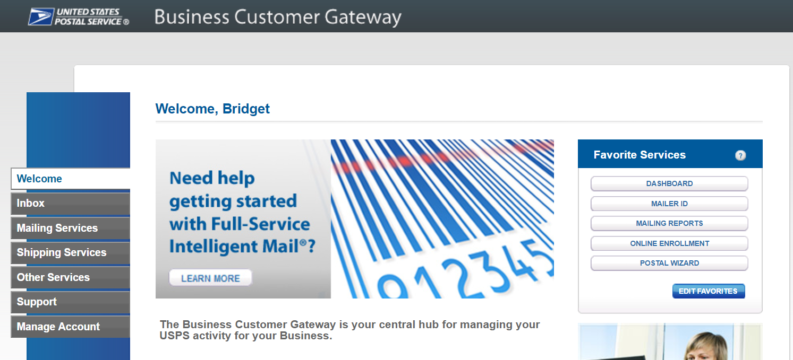
Then select “Manage Profile” at the top and “Add A Location” to add the CRID to your profile.
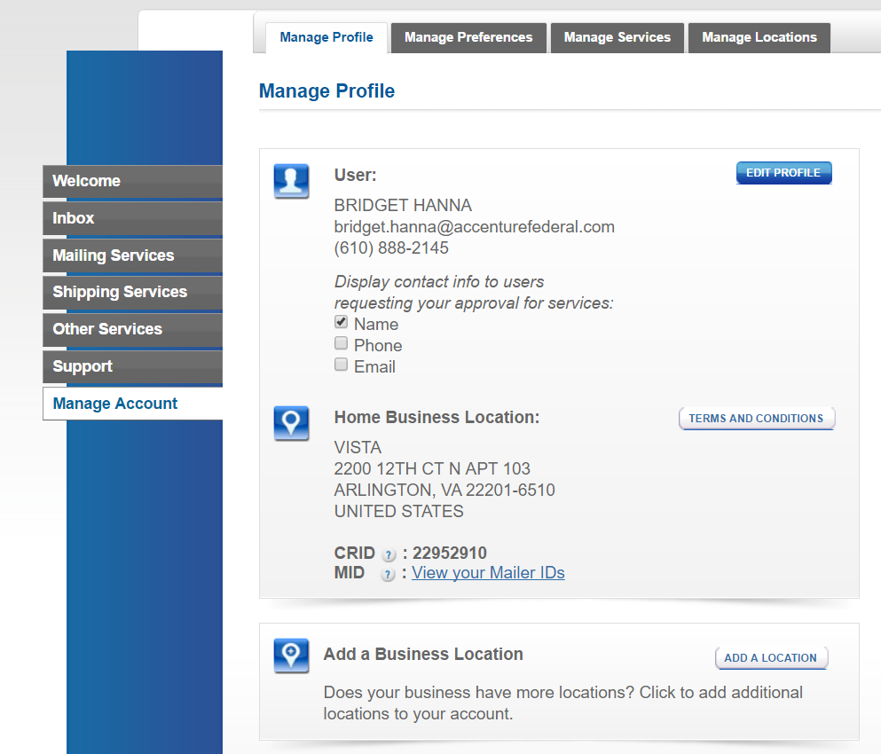
Jim’s Candies
Jim Brown

You may now request access to Enterprise Payment. Select “Other Services” on the left hand side. Then select “Go to Service” next to Enterprise Payment.
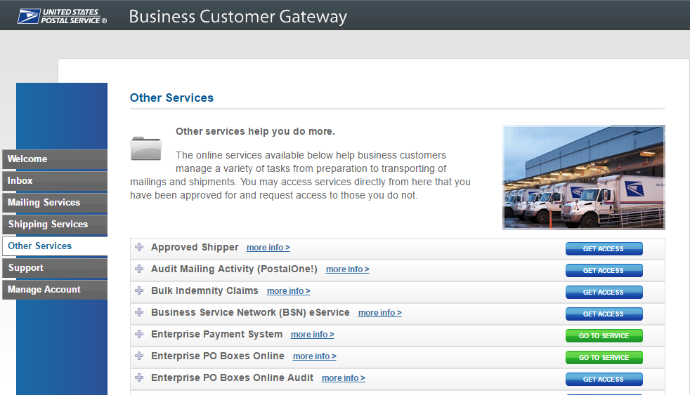
The designated BSA must now approve your request to EPS before you are given access.

Will I be able to view permits not linked to my CRID?
- EPS returns all permits that you have ‘Manage Mailing Access’ to in the BCG, this enables multiple permits to be tied to a central EPS account, but still maintain the permit to CRID linkage.

If customers want to manage accounts at the CRID level multiple EPAs can be established pulling from a central bank account. This enables authorization at the EPA level, so one person can view one EPA account, but not the other if need be.

As a Mail Owner how do I give my Mail Service Provider (MSP) access to an EPS account?
- To do so, the Mail Owner completes steps 3&4 of the process below:
  - The MSP logs into BCG and adds the CRID on that EPS account to the BCG account
  - MSP requests access to EPS service under that CRID
  - BSA (assumed to be Mail Owner) grants access to EPS Service to MSP BCG user
  - EPS Account Administrator adds MSP BCG user to the EPS Account
    - for read-only report access, the role granted is Subscriber
Note: This will grant the MSP user access to view ALL transactions on the EPS reports, even if some transactions were made by other MSPs.
Today separate groups manage different postal products; when we transition to EPA, will we be able to maintain the separate management/payment of each product?
- You can have multiple EPA's in which products can be linked to different accounts to keep the separation.
If we convert PO Boxes, ACS, and Business Reply Mail, will we have 3 separate EPA numbers?
- You have an option to use one EPA or multiple.

Mail Service Provider (MSP)
I am a Mail Service Provider (MSP). How do I set-up my customer’s EPA?
ACH Debit: The MSP will need to have access to the Mail Owner’s bank account information. The MSP will then need the Mail Owner to either:
- Enter the micro-debit verification transaction
- Give the values of the verification to the MSP to verify the account

Trust Account: The MSP would need to set-up an EPA on behalf of the Mail Owner. Then the MSP would fund the Trust Account. Note: A Trust Account is automatically set-up when the EPA is created.

I am a MSP and my customer has linked a permit to EPA. Can I present a combined mailing with permits linked to a CAPS account, a local trust and an EPA?
- Yes. The system will perform the following transactions based on the account type. The MSP can view the Postage Statement transaction details in PostalOne!. The customer will see the transaction for their portion of the mailing within EPS.

CAPS: The system will route the transaction amount to CAPS.
EPA: The system will route the transaction amount to EPA.
Local Trust: The funds will be withdrawn from the account.

As an MSP can I make a Mobile Check Capture deposit into my client’s EPA?
- Yes, you will need the 10 digit EPS Account number to make the deposit.
Can a customer transfer funds from their EPS to a MSP's EPS account?
- You cannot transfer funds online, however you can deposit cash, check or money order at any retail location using the 10 digit EPA number or you can do a FedWire or ACH Credit deposit.

As an MSP, we have mail owners that fill out a permit application and send a check for us to give to the local Post Office for opening a permit on their behalf. Will this still be an option or will the mail owner need to set up an EPS in the BCG?
- The mail owner would need to set up their EPA or the MSP could open the permit under their CRID and EPA.

As an MSP, I am able to use the BCG to verify a client's permit number and the account number for that permit. If a client changes to EPA will the account number in the BCG be updated (and maybe indicate it is an EPA account)?
- Yes, this will be updated to include the 10 Digit EPA.

How does this new system affect my company as we mail for multiple customers using their permits and CAPS accounts, and use both Mail.dat files and PostalOne!?
- The new system will not affect your mailing processes, the payments for transactions linked to EPS will flow through the system. If you use the account number in the .mpa field this will need to be updated to the new EPA number.

If a client pays me, MSP, with a check made out to the USPS / US Postmaster, can I deposit that check to my EPS account? In most cases our clients pay for their mailings by making a check out to our company and we fund through our CAPS account.
- Yes, you can deposit into your EPA. The holder of the EPA is responsible for any negative balances, check returns etc.

Funding Mail Owner’s Account as an MSP
- MSPs have the ability to deposit money into a Mail Owner’s Trust Account without an assigned role to the account.
- Directly deposit funds into a mail owner’s EPA using the following methods:
Funding Method | Description | Account Information Needed from Mail Owner | Deposit Available
Automated Clearing House (ACH) Credit | Electronic method to deposit funds into your account directly from your banking institution | - Bank Name  - Routing Number  - Bank Account Number | - Next day
Fedwire Transfer | Service provided by the Federal Reserve bank to electronically deposit funds into your account | - Bank Name  - Routing Number  - Bank Account Number | - 4 to 6 hours
Deposit at Retail Unit | Deposit check, cash, or money order at designated retail units (https://postalpro.usps.com/EPS/RetailLocations) | - 10 digit EPS Account Number | - Near real-time  - A limited number of retail locations do not have real-time processing. In these cases, funds are available the next business day, but mailings are not held.
Mobile Check Capture | Capture a check image, using the camera on your Android smartphone, iPhone or iPad, and deposit funds from anywhere | - 10 digit EPS Account Number | - 1 to 2 hours

As a MSP, how do I gain access to a Mail Owner’s EPS Account to view transaction data?
- The Mail Owner must grant you access to their EPS Account. To do so, the MSP completes steps 1&2 below:
- The MSP logs into BCG and adds the CRID on that EPS account to the BCG account
- MSP requests access to EPS service under that CRID
- BSA (assumed to be Mail Owner) grants access to EPS Service to MSP BCG user
- EPS Account Administrator adds MSP BCG user to the EPS account
  - for read-only report access, the role granted is Subscriber

User Access
What are the user roles for EPS?
- The first person to request access to EPS is assigned the Administrator role. The Administrator will approve/deny additional users who request access.

Administrator:
- Grant access for additional EPS users
- Manage payment account (open/close accounts, approve products to be paid through account, perform transfers and withdrawals)
- View and download payment transaction reports

Payment Manager:
- Manage payment account (open accounts, approve products to be paid through account, perform transfers
- and withdrawals)
- View and download payment transaction reports

Subscriber:
- View and download payment transaction reports

Can I request access and have the request go directly to the BSA?
- Yes, the notification goes to the BSA or anyone the BSA has made an Administrator.

I am a Mail Owner, how do I give someone access to my EPA?
- The person requesting access must sign-in to the BCG and add the CRID associated with the account, and request access to EPS through the BCG.

The steps for this process are outlined in Section 3.6, Adding a Location (CRID), of the Payment Modernization Enterprise Payment System document located on PostalPro. Then the EPA Administrator for your account needs to sign-in to the BCG and grant the access level next to the name of the person requesting access.

The steps for this process are outlined in Section 3.4, Business Service Administrator (BSA) of the Payment Modernization Enterprise Payment System document located on PostalPro.

What EPS activity will be visible to the person requesting access to my EPA?
- Granting a person any access level to your EPA will allow them to see all transactions associated with your account. It is not limited to the ones they are involved in.

What EPS role do I need to access EPS transaction reports?
- You can view the Transaction Report with any user access – administrator, payment manager or subscriber read only.

Can more than one administrator be assigned to a single EPS account?
- Yes.

Can my BSN specialist assigned to my company have access to my accounts so she can help me?
- The BSN does not have access to your accounts, however you can contact the PostalOne! Helpdesk or your local BMEU for assistance.

Can we have multiple employees able to log into the EPS system?
- Yes, each employee will have need a unique BCG login and can be granted access to the EPS.

I have been asked to become the BSA for EPS and I am still pending invitation. How do I go about getting approved?
- You have to have an invitation code. If you have requested one please follow up with your local BME.

Can you make more logins with limited capabilities that members of accounting can use without being able to make changes accidentally elsewhere?
- Yes, there are different roles (Administrator, Payment Manager, and Subscriber) within the EPS.

Centralized Account Processing System (CAPS)
If I sign up for my Enterprise Payment Account (EPA) using my CAPS account, will my CAPS account number be used as my EPS account number?
- The EPA number will be your CAPS account number beginning with “90000” to reach the 10 character requirement for an EPA number.

I’m a mailer who uses multiple CAPS accounts. Do I need a different EPS invitation code for each CAPS account?
- No, the EPS invitation code allows you to initially sign-in and access EPS. From there you can setup multiple EPS accounts however you see fit.

I currently have multiple CAPS accounts, will I be required to create the same number of EPS accounts or can I consolidate them to a single EPS account?
- EPS accounts do not need to recreate the exact linkage of your organization’s current permits-to-CAPS account configuration. Any permits currently linked to a CAPS account can be linked to your EPAs in any configuration you choose (provided you have access to the permits based on the CRID being used on the EPA).

I know Mail Anywhere works with a CAPS account. However in the Mail.dat file, it requires the sender to put in the account number for the mailing. If multiple permits have the same account Number, will the system still accept the mailing?
- Yes, the mailer would provide the EPS Account number instead of the CAPS account number.

Can you transfer funds from CAPS to EPS when it is set up?
- The funds will transfer automatically upon final permit or service linkage. Example: If all permits are linked to EPS but the CAPs account is used to pay for Address Quality products the balance will not migrate until you link your address quality products.

If we have a CAPS Account, do we have to re-set up all banking information with the ACH Debit, or can the stored CAPS information be transferred over when moving to the new system?
- Yes, due to the additional security added within the EPA and the validation of bank account information.

Will we be able to use the CAPS ref# on the bank statements to charge different GL accounts for different budgets/groups/affiliates?
- Yes, this information is passed on to EPS

Will we be able to use our current payment method used for our CAPS?
- Yes, EPS allows ACH Debit, and Trust funded by cash, check, money order, FedWire and ACH credit deposit.

For CAPS we use a vendor as middle man to manage payments; does EPS eliminate the vendor and mailer can pay directly to the USPS?
- EPS does not change the process, either a vendor can be used or the mail owner can establish their EPA.

Currently, clerks at BMEU will check to see if sufficient funds are in deposit in the CAPS account. If using ACD Debit for EPS, will the clerks accept mailing with expectations of payment at end of day?
- Yes, the transactions will be finalized in PostalOne! and sent to EPS.

Is the CAPS system going away? If yes, what date will CAPS no longer available for use.
- The CAPS system is being replaced by EPS, we do not have a date for retirement, however we strongly encourage that mailers start the migration process.

We use CAPS and if we didn't have enough money in our account (by accident), our mail would not go anywhere. With this new system, if our account doesn't have enough funds to cover a particular mailing, will our mail be held up until funds are added?
- Yes, the process will remain the same as it is today. We encourage mailers to use ACH debit for this reason.

Does CAPS need to be contacted to cancel an existing CAPS account once transition to EPS is complete?
- Upon final product/service linkage the CAPS account will be closed without further interaction needed.

Transactions
How can I check my account balance to see if I have enough funds to cover a mailing?
- The account balance for each EPA you have access to will show on your EPS home page. Additionally, the BME clerk has access to the account balance through their “Balance and Fees” screen in PostalOne!.

Do I still have to make deposits at my local office where the permit is held?
- No, deposits can be made at any retail location that has an RSS. A list of location can be found on PostalPro here: https://postalpro.usps.com/EPS/RetailLocations

What information is required to make a deposit?
- You will need to know your 10 digit EPS Account number. Note: The retail location will not be able to find this information. If you do not know your 10 digit EPS Account number you will need to contact your local BMEU.

Where do I see deposits made?
- Deposits made to your account will be displayed in the Transaction History report.

After a deposit is made, how long does it take for the deposit to reflect in my EPS Trust account balance?
- A deposit made at retail will update the balance in near real-time.
  - A limited number of retail locations do not have real-time processing. In these cases, funds will be available the next business day. However, mailings will not be held.
  - A deposit made via Wire Transfer will update the balance within 4 to 6 hours.
  - A deposit made via ACH Credit will update the balance as part of an overnight process.

Can I use a credit card to pay for all products with my EPS account?
- No, the only products planned to allow Credit Card are Stamps Fulfillment Services products (e.g., StampsNow).

Can a check made out to a specific Postmaster’s City be deposited at any Post Office?
- Yes, any Post Office can accept checks made out to a specific city.

When does an ACH Debit get processed from my EPS account?
- The debit transactions are aggregated daily and sent to your bank for withdrawal, generally within 1-2 business days.
Can I transfer money from an EPS permit to a non-EPS permit?
- No, you cannot transfer from EPS permit to non-EPS permits.
- You can transfer from EPS Trust to EPS Trust if you have authorization as Payment Manager or Administrator to both EPS accounts.
- If you don’t have these permission you can still make a deposit at an RSS as long as you have the EPS account number.
What payment options are most of your customers selecting?
- ACH Debit is the most frequently used method.
Can a Trust Account run into a negative balance?
- It can if an override is performed by the BME acceptance employee.
We have a Local Trust as well as an ACH Debit tied to the same EPA#. How do we indicate which account to use at the time of mailing?
- In the EPS you can identify which account to use as the primary payment method.
If I drop off 7 jobs will the bank submission be one line item for all jobs or will there be 7 individual submissions (one for each job) to the bank account?
- There will be one aggregated withdrawal from your bank account. Within EPS they will show as individual transactions.

EPOBOL
Can I use the same EPS account for EPOBOL to pay for mailing services such as return mail, permits, etc.?
- Yes, you would need to link the mailing services permits to your same existing EPS account that is being used for EPOBOL.

I use EPOBOL, can we also pay our Post Office Box Renewal Fee?
- Yes, you can pay your renewal fees through the EPOBOL system linked to your EPA.

Stamps
Do pre-cancelled stamps need to be linked to an EPA?
- Yes, you will have to link your pre-cancelled permit to EPS.

If I am doing a Metered (MT)/Pre-cancelled (PC) Stamps mailing with additional postage due, do my permits have to be linked?
- No, you can use a combination of permits/payment types when entering a statement with additional postage due.
How can customers use EPA to purchase stamps?
- The StampsNow program will be moved to Enterprise Payment System in late Summer early Fall 2018.

How will EPS affect mail houses that received cash advance to purchase pre-cancel stamp and mailings that don't meet 200 pieces threshold for standard mail and 500 pieces for FCM?
- Stamp purchases will come in late Summer early Fall 2018 and you will be able to pay using your EPA.

When you say Pre-cancelled stamps do you mean we can buy them through EPS instead of using StampsNow? Or will they still need to be purchased through StampsNow?
- The StampsNow system will be integrated with EPS to enable payment for purchases using your EPA late Summer early Fall 2018.

Will this system replace Stamps.Com for CPU or Contract Postal Unit transactions?
- Yes, the systems will interface together. Stamp purchases will be accessible through a link in the BCG.

Business Reply Mail (BRM)
What about paying for BRM, accounting fees, etc that we use CAPS today. When will this be migrated to EPS?
- These products are supported under EPS today.

Will transfers between BRM accounts in different finance numbers be supported?
- All BRM accounts will be linked to one EPA account thus allowing the balance to be shared across accounts.

Will we still receive the daily receipts from the US Postal Services with Business reply and Postage dues?
- Yes, you will continue to receive your daily receipts from the USPS.

Reports/Data
What EPS data will be available on the Business Customer Gateway home page?
- As part of a future enhancement, users will be able to view summary spend data on a specific CRID or Permit from the Business Customer Gateway home page.

What capabilities will I have for gathering large sets of recurring data?
- A Bulk Data Transfer is planned for a future release, which will allow mailers to choose certain data they want to have pushed to them on a given interval.

What other future reporting capabilities are planned?
- USPS will build a transaction reporting datastore with detailed transaction level data on all EPS and PostalOne! products. This includes EPS transaction data from all EPS source systems as well as PostalOne! detailed postage statement data. Users will be able to view this data through a separate interface that will allow increased capabilities for customized reporting. Full details on the data elements included in the data store will be distributed to mailers as they become available.

Where does your permit ending balance show in EPS?
- The ending balance shows on the homepage of EPS when you login. You no longer drill into Transaction Report to see the balance.

How do I print out the EPS report? The report font prints very small and unreadable.
- In the Print Window, select Custom Scale and decrease the percentage until the page is scaled to display the report fully on one page. See images below:

- Below, at 100% scale, part of the report is not in the print window. The scale must be reduced for the report to fit on one page.
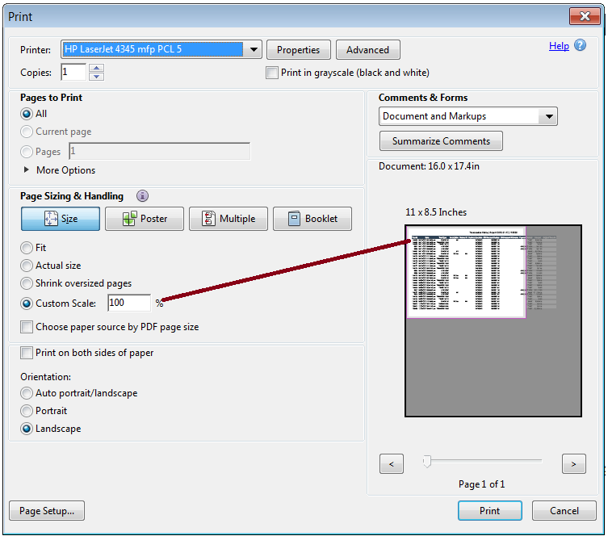

- Below, the scale has been reduced to 78%. The report is no longer hanging off of the page to be printed. The printed report is bigger and easier to read.
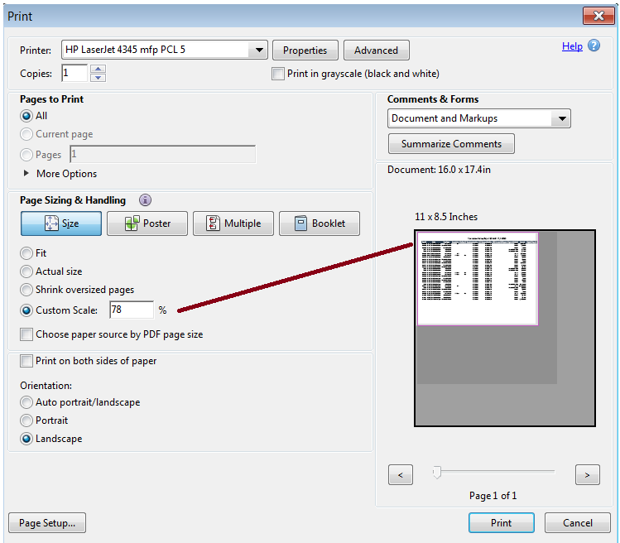

Can I limit what is shown in reports (e.g., can I just run a Permit Imprint report)?
- The EPS reports do have a filter capability.

Will these reports replace the mailing summary reports available on the gateway or in addition to because they are tied directly to the financial side?
- Both sets of reports will remain in place until a later date at which USPS will consolidate views.

Do the transactions reports include the PO Box, Caller or permit number as well as city, state?
- PO Box or caller is not displayed on transaction history report or PO BOxes Details report.
- City/State is displayed on PO BOxes Details report. (Box/caller ID is not assigned until the box is validated in webBATS.)
- For PotalOne! Transactions, the permit number/type/City/State/ZIP are not displayed on the transaction history report.
- Permit number/type, City/State is displayed on mailing details report for purchases, but not for adjustments, reversals or refunds.

Is there a way we can put our internal identifiers so we can use the transaction reports to reallocate charges to business units?
- The accounts can have nicknames associated to them.

Can the Job ID (our internal job number, submitted in mail.dat) of a mailing be included in reports?
- Job ID is not on the Transaction History Report but it is available on the Mailing Details Report and the Mail Class drill down from the Account Overview page.

Are reports customizable?
- No, but there are capabilities to filter the data.

Periodicals
How do I link my Periodical Publication to my EPA?
- The request would need to be initiated from EPS, like any other migration request, and the permit/publication number will be linked to an EPS account.

As a Periodical mailer, how does EPS affect additional entry sites?
- Creation of additional entry offices should not be affected at all, creation of additional entry offices will continue to occur and the PE being linked to an EPS account should not make a difference to the current procedure/process.

If I am a Centralized Postage Payment (CPP) customer, when will I see the funds withdrawn from my EPA?
- The funds will be withdrawn when the mailer/BMEU schedules a payment/if a payment is not scheduled then the mailer will be charged 28 days from the mailing date on the postage statement

If I am a Pending Periodical (PP) mailer how will this work in EPS?
- Mailers would need to link their PP permit and continue to process their mailings using the EPA. When the mailer requests for this PP account to be migrated, PostalOne! will transfer the available balance to EPA, PO! will continue to track/account for the reserved balance. Once the PP is approved, the reserved balance on this PP will be transferred to the Periodical account created. If, and when, the Periodical is linked to the EPA, the permit balance is transferred to the EPA. If the Periodical does not get approved, then a Permit Imprint is created.

Permits
What happens with existing balances on permits when the permit is now added to EPS with ACH payment? Will the balance be used first prior to pulling funds from the bank account?
- Permit balance will migrate the the EPS Trust balance when the permit to EPS account linkage is made (except CAPS when all permits for a CAPS account must be linked before the balance migrates.) If the primary payment method on the EPS account is ACH Debit, all transactions will be paid via ACH Debit from the linked bank account. If the primary payment method on the EPS account is trust, the trust will be used to pay for the transactions.

Will I be able to pay for a customer's mailing using their permit while they still pay for their own mailings using their deposit account?
- Yes you can continue paying for customer mailings and they can also pay for their own.

Who can help us gather info on our permits? We have many locations and legacy subsidiary names. City state of permit. Does it include PO box and caller numbers?
- The USPS PostalOne! Helpdesk or your local BME can assist with your permit information. PO Box and Caller Service is currently supported.

What happens to the current balance on a permit at my local BMEU?
- Upon final permit linkage any remaining balance will migrate to your EPA.

Do you have to be the permit holder in order to link a permit to your account?
- You must have Manage Mailing Activity and EPS role for the CRID to which the permit is linked in order to establish or modify linkages.

In a combined mailing we have multiple permits. Some permits owned by the MSP and some owned by the Mail Owner. As we transition will it be OK to use some permits linked to CAPS and other permits linked to EPA within a mailing?
- Yes, you can have a combination of payment methods in one mailing.

Mail Anywhere
Can I use Mail Anywhere with EPS?
- Yes, the mailer would provide the EPS Account number instead of the National Account Number.

Postage Statement Changes
What changes are there for submitting the different types of Postage Statements (hardcopy, PW, .dat, .xml)?
Type | Changes
BMEU Hardcopy Submission | - No changes; continue using existing permit number.  - If you enter information in the CAPS reference ID field this will be sent to EPS and displayed on transaction reports.
Postal Wizard | - No changes; continue using existing permit number, account number displayed will reflect Enterprise Payment Account.  - For Mail Anywhere jobs continue entering the mailing facility location.
Mail.dat | - Continue entering the permit number or publication number in the existing .mpa publication field or permit number field.  - The .mpa account number field remains optional, however if populated it must match the Account Number linked to the permit number.  - For Mail Anywhere update the .mpa account number field with the Enterprise Payment Account Number.  - If you enter information in the CAPS reference ID field this will be sent to the EPS and displayed on transaction reports.
Mail.XML | - Continue entering the permit number or publication number in the existing Permit Number/Publication field.  - The account number remains optional, however if populated it must match the Account Number linked to the permit number.  - For Mail Anywhere update the payment account number field with the Enterprise Payment Account Number.  - If you enter information in the CAPS reference ID field this will be sent to the EPS and displayed on transaction reports.

Security
Can Postage Due Accounts be migrated to EPS? What is the security level of this account? Who has access to this account?
- Postage Due can be migrated to EPS. Access to the account is restricted to the BCG user as granted access by the BSA. The bank account information is securely input outside of EPS and tokenized for security.

What security do we have to prevent unauthorized mailings?
- If any unauthorized activity occurs USPS has the ability to suspend the account while researching the suspicious transaction.

Are security settings available to allow a user to run reports and view transactions only?
- Yes, you can grant someone the “Subscriber” user role which allows them to view reports.

Miscellaneous
My company merged and we are going to eventually combine all into one EPS account, should I migrate my CAPS to EPS now or wait?
- You can begin the migration now.

Is package intercept supported by EPS?
- This will be supported at a later date.

Will vendors be forced to use one CRID?
- Vendors can use multiple CRIDS as they do today.

Will there be an external link to access the EPA or is it strictly through the gateway?
- The user will have to set up a BCG account to access the EPS.

When is EVS and PRS expected to be supported?
- To be determined.

Why can't a CRID be deleted from your BCG account?
- If you are not the BSA for the CRID, the BSA for the CRID can change your role for any service for that CRID to "no access."

Can I email a postage statement from that site directly to a customer? If not, can I download a pdf of postage statement so that I can email it to them?
- A PDF of the postage statement can be downloaded from the BCG and emailed to the customer.

I saw in the NPF brochure a mention of a new digital currency for the post office - Mailcoin. Do you plan to attempt this as future payment?
- We do not have this currently in our deployment schedule.

Will any interest be paid on balance of money held in the EPS Account?
- No interest will be paid on balances.

Whom on a local level would I gather more information about this system. My BMEU clerk or local postmaster?
- Contact your local BMEU.

We often receive BREs back with a stamp affixed. We submit those stamped BREs for a refund, we normally receive a check for a refund - can those checks be linked to our EPS to go via ACH back into our acct rather than waiting on a check to be mailed?
- Refunds will be made directly to your EPA.

Will the paper submission be changed to electronic?
- Yes, this process eliminates most paper transaction processes.

How will EPS affect VAR?
- VAR's will now be deposited into your EPA, eliminating the need to cut a paper check.

